**EXPERIMENT:8**

**Practice Queries using Aggregate functions, Group By, Having Clause and Order by Clause**

**AVG:**

select avg(age) from table1;

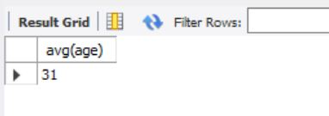

**COUNT:**

select num_value,COUNT(age) from table1 GROUP BY

num_value;

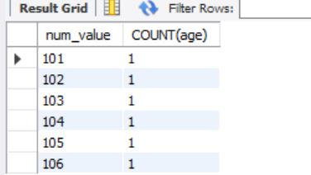

**MAX:**

select num_value,name,age from table1

where age = (select MAX(age) from table1);

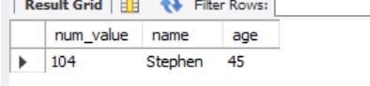

**MIN:**

select num_value,name,age from table1

where age = (select MIN(age) from table1);

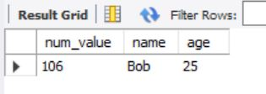

**SUM:**

Select sum(age) from table1;

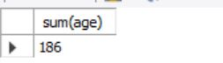

**GROUP BY:**

select num_value,COUNT(*) age from table1

GROUP BY num_value;

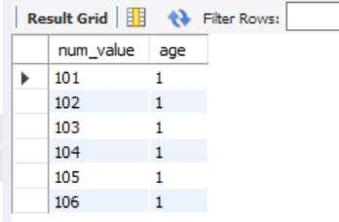

**ORDER BY:**

select num_value,name,occupation,age from

table1 ORDER BY age asc**;**

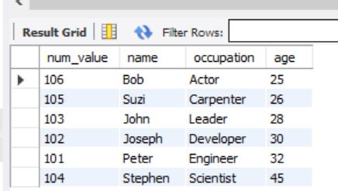

**HAVING BY:**

select num_value,name,COUNT(age)

occupation from table1 where num_value IS NOT NULL

GROUP BY num_value;

